Cell Requirements – Energy, Nutrients, and Waste Removal

Every living cell is a tiny factory. It never stops working. It needs raw materials (nutrients). It needs power (energy). And it must take out the trash (waste removal). From the moment a cell is born until it divides or dies, it constantly exchanges matter and energy with its surroundings. Yet most people never consider what a cell needs to stay alive — or how plants have solved the energy problem in a completely different way than animals.
Biology is not merely a subject taught in classrooms. It is the study of how life sustains itself. From the smallest bacterium to the largest redwood tree, from the neurons in your brain to the muscle cells in your heart, every cell requires energy, nutrients, and waste removal. Understanding cell requirements means understanding why you need to eat, breathe, and eliminate waste — and how plants feed themselves (and the rest of the planet) using nothing but sunlight, water, and air.
This reading material explores the fundamental requirements of all cells, the process of photosynthesis in autotrophs, the role of chloroplasts, and the critical function of chlorophyll and other pigments in capturing light energy.

Part 1: What Do All Cells Require and Why Does It Matter?

The Three Universal Requirements of All Cells
Every living cell — whether prokaryotic or eukaryotic, plant or animal, bacterial or human — has three non-negotiable requirements:

Requirement | Why Cells Need It | What Happens If Missing
Energy | To power chemical reactions, transport molecules, grow, and divide | Cell stops functioning; death within  minutes to hours
Nutrients | To provide raw materials for building cellular structures (membranes, proteins, DNA) and to serve as energy sources | Cell cannot grow or repair itself;  eventually starves
Waste removal | To eliminate toxic byproducts of metabolism (carbon dioxide, ammonia, urea) | Toxins accumulate; pH changes; cell  poisoning occurs

Why Cell Requirements Matter in Biology
Aspect | Explanation | Examples
Survival | Cells cannot live without continuous energy and nutrient supply | Brain cells die after 3-5 minutes  without oxygen (needed for energy)
Metabolism | All chemical reactions in cells depend on energy and raw materials | Building proteins requires energy  (ATP) and amino acids (nutrients)
Homeostasis | Waste removal keeps internal conditions stable | CO₂ buildup lowers blood pH  (acidosis), which can be fatal
Nutrition | Understanding cell requirements explains why organisms need food | Humans need carbohydrates, fats,  proteins, vitamins, minerals
Medicine | Many drugs target cell requirements to treat disease | Chemotherapy targets rapidly dividing  cancer cells' energy needs

How Different Cells Obtain Energy and Nutrients
All cells fall into two categories based on how they obtain energy and nutrients:

Autotrophs (Self-Feeders)
Definition: Organisms that produce their own food from inorganic sources
Energy Source: Light (photoautotrophs) or chemicals (chemoautotrophs)
Carbon Source: Carbon dioxide (CO₂)
Examples: Plants, algae, cyanobacteria

Heterotrophs (Other-Feeders)
Definition: Organisms that obtain energy and nutrients by consuming other organisms
Energy Source: Chemical bonds in organic molecules (food)
Carbon Source: Organic compounds (sugars, fats, proteins)
Examples: Animals, fungi, most bacteria

Key insight for students: Autotrophs are the producers of the biosphere. Heterotrophs are the consumers. Without autotrophs, heterotrophs would have no food or oxygen.

Part 2: Photosynthesis – How Autotrophs Capture Energy
Photosynthesis is the process by which autotrophs (plants, algae, and cyanobacteria) convert light energy from the sun into chemical energy stored in glucose (sugar). This glucose is then used by the cell for energy or built into other organic molecules.
The overall balanced chemical equation for photosynthesis is:



Where Photosynthesis Occurs – The Chloroplast
Photosynthesis takes place within specialized organelles called chloroplasts. These are found only in the cells of autotrophs (plants and algae). Prokaryotic autotrophs (cyanobacteria) do not have chloroplasts; they have chlorophyll embedded in folded membranes.

Structure of a Chloroplast (Draw this)
Part of Chloroplast | Description | Function
Thylakoid | Flattened, disk-shaped sacs arranged in stacks | Light-dependent reactions occur  here (chlorophyll embedded in  thylakoid membranes)
Grana (singular: granum) | Stacks of thylakoids | Increases surface area for light  absorption
Stroma | Fluid-filled space surrounding the thylakoids | Light-independent reactions  (Calvin cycle) occur here
Chlorophyll | Green pigment molecule embedded in thylakoid membrane | Captures light energy (absorbs blue  and red light; reflects green)

Chloroplasts Are Found Only in Autotrophs
Organism Type | Contains Chloroplasts? | Where Photosynthesis Occurs
Plants (leaves, green stems) | Yes | Chloroplasts in mesophyll cells
Algae | Yes | Chloroplasts
Cyanobacteria (blue-green algae) | No (prokaryotes) | Chlorophyll in folded thylakoid-like membranes
Animals | No | Cannot perform photosynthesis
Fungi | No | Cannot perform photosynthesis
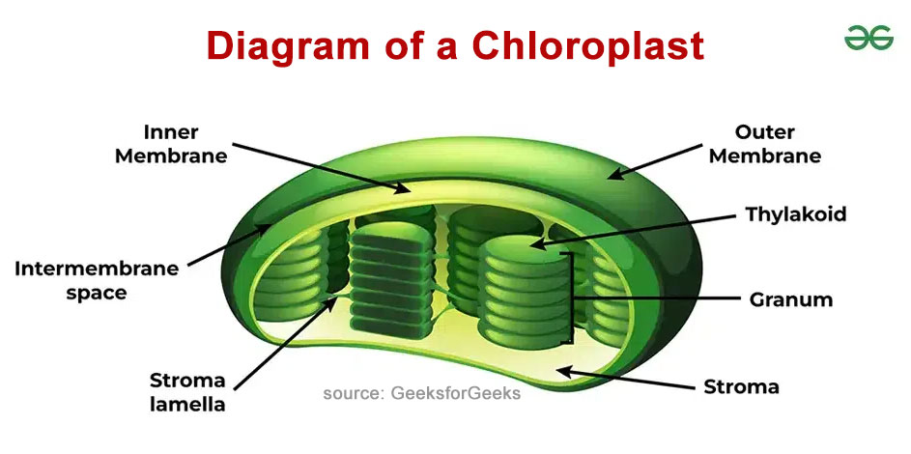

Part 3: The Role of Chlorophyll and Other Pigments
Chlorophyll is the primary pigment that captures light energy for photosynthesis. However, plants contain several pigments that work together to maximize light absorption.

Types of Photosynthetic Pigments

Chlorophyll a
Color: Blue-green
Wavelengths Absorbed: Red light (660-665 nm) and violet-blue light (430-450 nm)
Wavelengths Reflected: Green (this is why plants look green)
Role: Primary pigment; directly converts light energy to chemical energy

Chlorophyll b
Color: Yellow-green
Wavelengths Absorbed: Blue and orange light
Wavelengths Reflected: Yellow-green
Role: Accessory pigment; captures light and transfers energy to chlorophyll a

Carotenoids (beta-carotene, lutein)
Color: Yellow, orange, red
Wavelengths Absorbed: Blue-violet light
Wavelengths Reflected: Yellow, orange, red
Role: Accessory pigments; protect against excess light (photoprotection); give autumn leaves their colors

How Pigments Capture Light Energy
Step | What Happens
1 | Light strikes the pigment molecule (chlorophyll or accessory pigment)
2 | The energy from light excites electrons in the pigment to a higher energy level
3 | Excited electrons are transferred to electron acceptor molecules
4 | This energy is used to make ATP (energy currency) and NADPH (electron carrier)
5 | Accessory pigments pass their captured energy to chlorophyll a

Why Plants Have Multiple Pigments
Plants do not just have chlorophyll a. They have a team of pigments for two reasons:
Reason | Explanation
Capture more of the light spectrum | Chlorophyll a absorbs mainly red and blue light. It does NOT  absorb green or yellow light well. Carotenoids and chlorophyll b  capture light in other wavelengths (blue-violet, orange) and pass  the energy to chlorophyll a.
Protection from excess light | Too much sunlight can damage chlorophyll and cell structures.  Carotenoids absorb excess energy and release it as heat,  protecting the cell from damage. This is called photoprotection.

Visible Light Spectrum and Pigment Absorption
Color of Light | Wavelength | Absorbed by Which Pigment?
Violet | ~400 nm | Chlorophyll a, carotenoids
Blue | ~450 nm | Chlorophyll a, chlorophyll b, carotenoids
Green | ~550 nm | Poorly absorbed (reflected) — plants appear green
Yellow | ~570 nm | Chlorophyll b, carotenoids
Orange | ~600 nm | Chlorophyll b, carotenoids
Red | ~660 nm | Chlorophyll a
Key point: Plants are green NOT because they need green light, but because chlorophyll reflects green light while absorbing red and blue light.

Part 4: The Two Stages of Photosynthesis
Photosynthesis occurs in two main stages: the light-dependent reactions and the light-independent reactions (Calvin cycle) .
Feature | Light-Dependent Reactions | Light-Independent Reactions
Location in chloroplast | Thylakoid membrane | Stroma (fluid)
Requires light? | Yes — light required | No — can occur in dark (but needs  products of light reactions)
Inputs | Light, H₂O, ADP, NADP⁺ | CO₂, ATP, NADPH
Outputs | O₂ (oxygen), ATP, NADPH | Glucose (C₆H₁₂O₆), ADP, NADP⁺
Role of chlorophyll | Captures light energy to excite electrons | No direct role (uses ATP and NADPH  produced in light reactions)

Part 5: Connecting Cell Requirements to Photosynthesis
Autotrophs like plants meet all three cell requirements through photosynthesis and related processes:
Cell Requirement | How Plants Meet It | Role of Photosynthesis
Energy | Glucose produced by photosynthesis is broken down in cellular respiration to make ATP | Photosynthesis captures light energy  and stores it as chemical energy in  glucose
Nutrients | Plants absorb water (roots), CO₂ (leaves), and minerals (nitrates, phosphates, etc. from soil) | CO₂ and H₂O are direct inputs to photosynthesis; minerals are used to  build enzymes and structures
Waste removal | Oxygen (O₂) produced during photosynthesis diffuses out of cells; other wastes are stored or recycled | O₂ is a "waste product" of the light-  dependent reactions

The Cyclic Nature of Life on Earth
Photosynthesis is the foundation of almost all life on Earth because it:
Contribution | Explanation
Produces oxygen | All atmospheric oxygen comes from photosynthesis (by plants and  cyanobacteria)
Produces food | Glucose from photosynthesis feeds the entire food web (directly or  indirectly)
Removes CO₂ | Photosynthesis reduces atmospheric carbon dioxide, regulating climate
Stores energy | Fossil fuels (coal, oil, natural gas) are ancient photosynthetic organisms

Key Terms
Term | Definition
Autotroph | An organism that produces its own food from inorganic sources  (e.g., plants, algae, cyanobacteria)
Heterotroph | An organism that obtains energy and nutrients by consuming  other organisms (e.g., animals, fungi)
Photosynthesis | The process by which autotrophs convert light energy into chemical  energy stored in glucose
Chloroplast | The organelle in plant and algal cells where photosynthesis occurs
Chlorophyll | The green pigment in chloroplasts that captures light energy for  photosynthesis
Thylakoid | Flattened membrane sacs inside chloroplasts where light-dependent  reactions occur
Grana | Stacks of thylakoids that increase surface area for light capture
Stroma | The fluid-filled space inside chloroplasts where the Calvin cycle  occurs
Carotenoids | Yellow, orange, and red accessory pigments that capture additional  light and provide photoprotection
Light-dependent reactions | The first stage of photosynthesis; requires light; produces O₂, ATP,  and NADPH
Calvin cycle | The second stage of photosynthesis; does not require light directly;  uses CO₂, ATP, and NADPH to produce glucose
ATP | Adenosine triphosphate; the energy currency of the cell

Review Questions
Responses should be written on a separate sheet of paper.
1. List the three universal requirements of all cells (energy, nutrients, waste removal). For each requirement, explain why cells need it and give one example of a specific substance involved.
2. Identify where photosynthesis takes place within the cells of autotrophs. Your answer must include the name of the organelle, the type of cell that contains this organelle (plant, animal, or both), and which organisms are autotrophs.
3. Describe the role of chlorophyll and other pigments in capturing light energy. Your answer must include what chlorophyll does when light strikes it, the difference between chlorophyll a and accessory pigments (chlorophyll b and carotenoids), and why plants have multiple pigments rather than just one.
4. Explain why plants appear green to the human eye. Use the terms "absorb," "reflect," and "wavelength" in your answer.
5. Application question: A student places a green plant in a sealed glass container with no light. The plant has water and soil. Answer the following: Will the plant perform photosynthesis? Why or why not? What will happen to the plant over time, and which cell requirement is not being met?
6. Thinking question: If all autotrophs (plants, algae, cyanobacteria) suddenly disappeared from Earth, explain what would happen to oxygen levels in the atmosphere, carbon dioxide levels, and heterotrophs (including humans).

